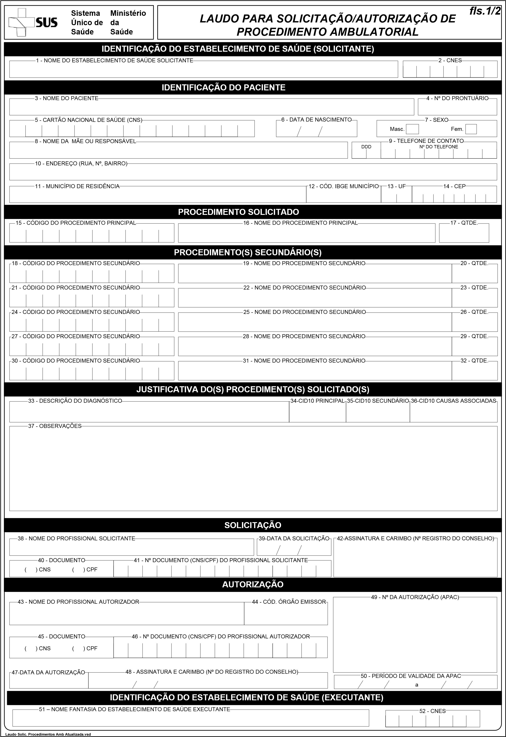

UBS

MILENA SOUZA LOPES

MT
2026

05596057142
x

1

